**International Journal of Science And Engineering**

[ISSN (Online):](http://oapub.org/edu/index.php/ejes)  2454-2016

[Volume 11 Issue 01 June 20](http://oapub.org/edu/index.php/ejes)25

**DOI:**

INNOVATIONS IN COASTAL SHIPPING: PROPULSION, SAFETY, REGULATIONS AND TRAINING FOR THE FUTURE SEAFARERS

**\*Mahesh Patil1*, Sanjeet Kanungo2**

*- Department of Marine Engineering, Samundra Institute of Maritime Studies, Pune, Maharashtra, India,* [*m.patil.m1975@gmail.com*](mailto:m.patil.m1975@gmail.com)

*- Department of Marine Engineering, Tolani Maritime Institute, Pune, Maharashtra, India,* [*kanungosanjeet@gmail.com*](mailto:kanungosanjeet@gmail.com)

***\*Corresponding Author:***

*Email:* [*m.patil.m1975@gmail.com*](mailto:m.patil.m1975@gmail.com)

**Abstract**

*Both operational modernization and a focus on the environment are driving big changes in coastal shipping. Recent achievements in technology, engines, employee learning and regulations concerning coastal ships are reviewed in this work. Hybrid and zero-emission forms of power such as batteries, technologies aided by wind and engines using LNG, methanol or ammonia are being pushed because they cut emissions and link to the targets of the International Maritime Organisation for reducing carbon. At the same time, advances in safety, like self-driving systems, smarter onboard navigation tools and resilient protection against digital threats, are altering how safe ships operate along crowded and environmentally sensitive coasts.*

*The development of cybersecurity standards and environmental regulations is having a big impact on this transition. As a result of these new technologies, organisations in Maritime Education and Training are creating engaging courses that target digital systems, alternative fuels and autonomous operations. Key strategies for MASS utilisation are presented, along with examples of regulatory modifications in maritime training and the use down to earth dual-fuel technologies. All these changes suggest that coastal shipping is switching to become more intelligent, secure and environmentally responsible.*

1. **KEYWORDS:**

* **Decarbonization**
* **Dual-fuel propulsion**
* **Maritime Autonomous Surface Ships (MASS)**
* **Cybersecurity**
* **IMO regulations**
* **Alternative fuels**
* **Electric propulsion**
* **ECDIS (Electronic Chart Display and Information System)**
* **Seafarer training**
* **Wind-assisted propulsion**

Copyright 2025 IJSE

Distributed under Creative Commons CC-BY 4.0 OPEN ACCESS

1. **LITERATURE REVIEW**

The need for safer ships, an eye on the environment and adherence to updated regulations is pushing important changes in coastal shipping. Together, better propulsion, enhanced crew safety, laws and crew training are updating the industry to become standard worldwide and respond to new demands of maritime transport.

Current studies show that new forms of propulsion are addressing the problem of greenhouse gas pollution and improving how efficiently ships use energy. Because LNG engines minimize SOx by more than 90% and NOx by roughly 85%, engines that steam liquefied natural gas, methanol or ammonia hold a lot of potential [1]. Though ammonia is both toxic and corrosive, it is zero-carbon and methanol’s positive handling characteristics make it a suitable alternate. By using wind energy in addition to regular engines, accessories like AirWing have been shown to bring down fuel use by 30% [3]. Battery-electric engines and cloud-based control make a big difference when it comes to zero-emission shipping, mostly for trips that stay near the coast [4].

The IMO’s goals for decarbonization are still a major priority. In addition to helping boats comply with safer rules for SOx and NOx emissions, hybrid and electric propulsion also support compliance with the IMO 2020 fuelsulfur limit. Thanks to integrated onboard power grids, it becomes simpler to move energy around and support renewable energy which leads to better performance during operations [6]. A review of the data confirms that incorporating wind power in fuel systems greatly reduces carbon emissions [7].

The coastal shipping industry can only improve its safety by using innovative digital tools. During harsh sea conditions, AI-integrated ECDIS displays help mariners be aware of their position and navigate safely [8]. In tests with artificial intelligence collision avoidance, accidents have been reduced by 15% [9]. In addition, the development of standard ways to communicate has helped maritime safety infrastructures through better information sharing between ships and shore teams [10]. Cybersecurity has now built up into a significant concern too. The Industrial Maritime Cybersecurity Standards Organization and the U.S. Coast Guard have brought in strong guidelines for dealing with maritime cyber risks [11, 12].

Because of these new technologies, the rules around banking are being updated. According to researchers, managing autonomous ships requires international consistency, proving they are safe, establishing legal responsibility and ensuring their technology is mature [13]. Modernizations make it possible for the industry to maintain good environmental performance, even if adhering to emission control laws raises the expenses by 5% to 10%.

During this shift, supporting employee learning is just as necessary. MET programs are also covering alternative fuels, digital technologies, cybersecurity and autonomous systems [16]. Low-risk learning with advanced tools and realistic simulations help prepare seafarers to adapt to new innovations and take on all sorts of tasks [17]. Smarter training methods that include both technical and flexible leadership skills are used instead of the old performance review methods [18].

Some of the key findings from the scholarly sources are changes in coastal shipping occurring because of new technology, better digital safety systems, new regulations and improvements in people and skills. Due to global changes such evolution supports the safe, effective and environmentally friendly operations in the maritime field.

1. **METHODOLOGY**

A qualitative approach is used in this study to look at the ongoing changes in coastal shipping by examining case studies, current literature and what experts think. The approach picks out significant trends, new developments, issues and changes in propulsion technology, safety systems, rules and the workforce by mixing a review of academic works with theme-based analysis.

To understand the most recent changes in coastal maritime operations, studied scholarly reports, industry pamphlets and official policies. The proof of theories depended on actual case study examples dealing with autonomous technologies, dual-fuel systems and integrating regulations. The progress of the sector was supported by valuable insights from maritime engineers, policymakers and training experts.

Advances in engine systems, steps made to improve safety, the latest ways to meet rules and training changes were all determined through thematic analysis. A comparative study of different cases helped in identifying both main practices and the issues involved in applying new technologies and policy frameworks. The relationship between human factors, new rules and developments in technology in the coast shipping industry was shown using a conceptual model.

The software NVivo made it possible to code and arrange the literature data more easily and this helped us recognize recurring themes and links. Consistent analysis of different scenarios was achieved due to the purposeful use of a case study method. Interviews with participants were conducted in a flexible way and the data were examined to find common topics.

If secondary data forms the main source of the study, some analysis might not be fully possible. In addition, the fast development of technology in the maritime sector could limit how long the findings remain useful. Because the research uses progress from areas with good maritime infrastructure, mainly Europe, there will be geographical limitations as well.

All the data used in this report was cited properly to maintain academic credibility. No identifying information about the participants or their groups was released. Every step of the study is consistent with accepted ethical research rules.

1. **INTRODUCTION**

The global maritime industry depends on coastal shipping for its support of regional commerce, the delivery of goods and coastal economies. The defense industry is going through major changes to respond to greater needs for safety, caring for the environment and meeting regulations. Better propulsion, greater attention to safety, improved rules and more training for seafarers are causing the shift. Unlike past studies, this work explores how these aspects relate and build on each other to progress sustainability in coastal shipping. Next-generation propulsion, alternative forms of energy, smart navigation tools and new training for seafarers are laying the basis for a better, safe and lasting workforce and fleet along coasts.

Because the maritime industry wants to reduce its emissions and impact on nature, new and improved propulsion technology is now developed and applied at a faster pace. The use of dual-fuel engines that run on liquefied natural gas (LNG), methanol, ammonia, and battery-electric systems is growing. Emissions like sulfur oxides (SOx), nitrogen oxides (NOx), particulate matter, and carbon dioxide (CO2) can be significantly reduced thanks to these systems [1]. They enhance overall performance and fuel efficiency in addition to promoting adherence to global standards like the Energy Efficiency Existing Ship Index (EEXI) and the IMO's FuelEU Maritime initiative.A forward-thinking approach to decarbonizing short-sea shipping, wind-assisted propulsion technologies such as the AirWing also present promising potential for the use of renewable energy sources and can reduce fuel consumption by up to 30% [2].\

**Figure 1** Curcio, E. (2025). INSIGHT: A Comparative Analysis of Alternative Fuels for Sustainable Maritime Shipping. Ship & Bunker. (REF: IMAGE 1)

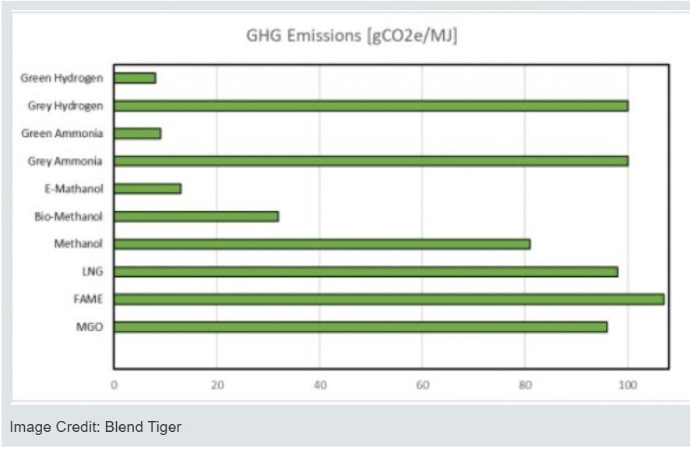

Improving the safety of electric vehicles is given equal attention with the development of powerful systems. Improved situational awareness and navigation accuracy are provided by contemporary digital navigation systems, such as AI-enhanced Electronic Chart Display and Information Systems (ECDIS) [3]. Thanks to these tools, ports with elevated danger and step restrictions can now run their vessels with reduced risk of accidents and harm to the environment. As well as helping ships use less fuel and cut their emissions, new technology practices improve safety. At the same time, an adaptable group of seafarers is vital for easily integrating advanced technology which is why upskilling workers is so important in this field.

With the advent of Maritime Autonomous Surface Ships (MASS) and the increasing complexity of vessel systems, Maritime Education and Training (MET) is changing quickly. Modules on digital system operations, cybersecurity, autonomous navigation, and alternative fuel handling are becoming more and more common in training programs [4]. Cutting-edge training facilities, like the ABS Singapore Maritime Safety Centre, create safe yet realistic learning environments by simulating real-world operational and emergency scenarios using virtual reality and gamified learning tools [5].Furthermore, multi-criteria decision-making (MCDM) models are now used in contemporary competency assessments, encouraging a comprehensive evaluation strategy that emphasizes not only technical skills but also critical thinking, leadership, and adaptability—qualities that are crucial in the maritime industry, which is undergoing technological change [6].

Innovation and sustainable actions are being promoted by new rules put in place by regulators which also oversee safety. In view of accepting new fuels, tougher emissions rules and more autonomous shipping, the rules set by international conventions and port state control are being modified. The expansion of alternative fuel bunkering systems and digital port facilities to enable effective ship-to-shore coordination and communication is a result of these changes, which also affect coastal infrastructure [7]. The coastal shipping sector can last for many years by being shaped through the coming together of technology, rules and experienced workers.

1. **MAIN BODY**
   1. **Innovations in Propulsion Systems for Coastal Shipping**
      1. **Present: coastal shipping propulsion (2025)**

Maritime transport by coast is gradually moving toward more eco-friendly, energy-saving and low-CO2 forms of ship propulsion. By the end of 2025, we could see hybrid diesel-electric propulsion, fully electric propulsion and some advanced wind-assisted technology board the industry’s stage. ABB using cutting-edge propulsion systems will build the Portuguese Navy’s first new Offshore Patrol Vessels. These ships will have ABB's Azipod drivelines and Onboard DC Grid™ electric systems which will provide improved manoeuvrability, operating performance, and lower emissions [9]. The AirWing system and others like it are designed to use aerodynamic forces to help engines consume 30% less fuel. Sea trials commencing in early 2025 are critical for validating operational robustness and scalability in coastal shipping contexts [10].

Electric propulsion systems, such as linked electric vessels assisted by cloud-based solutions, are a game-changer for zero-emission waterborne transport. These ships make use of energy efficient electric motors, advanced power management algorithms to optimized operational profiles, specifically for short haul coastal services [11].

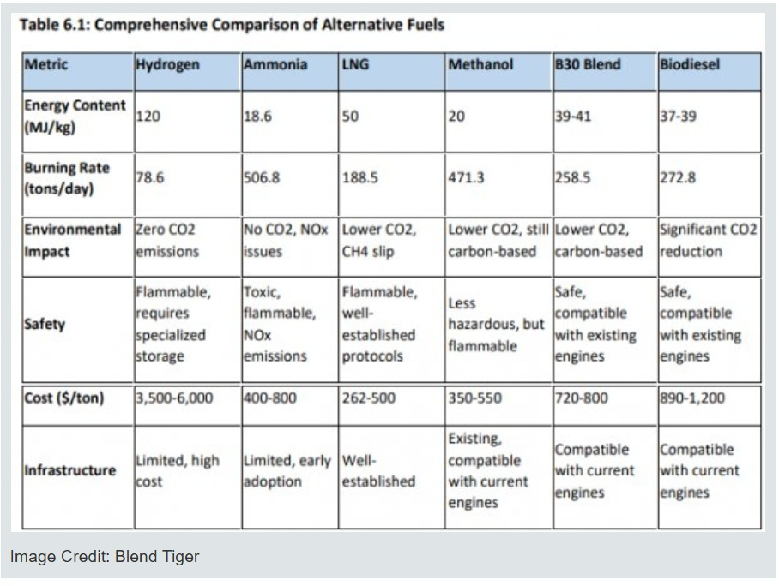

**Figure 2** Curcio, E. (2025). INSIGHT: A Comparative Analysis of Alternative Fuels for Sustainable Maritime Shipping. Ship & Bunker. (REF: IMAGE 2)

**6.1.2 Technical/Performance Specs and Benchmarks**

Hybrid Diesel-Electric Systems employ a diesel generator to generate electricity for electric propulsion motors to opportunity for load matching and fuel savings. For example, Siemens Energy BlueDrive systems offer modular power generation tailored to vessel size and mission profile [12].

With the help of a podded electric motor that can rotate 360 degrees, azipod propulsion units greatly increase maneuverability and do away with the need for rudders. Depending on the vessel class, typical power outputs fall between 1 and 10 MW, with efficiency gains of up to 15% when compared to traditional shaft lines [13].

Rigid, automated wings that adapt to wind conditions are used in wind-assisted propulsion (AirWing), which increases thrust. With operating limits determined by wind angle and strength, the AirWing system is compatible with retrofits and promises a 30% fuel savings under ideal wind conditions [10].

Battery storage systems, electric motors, and cloud-based monitoring for route optimization and predictive maintenance all have been part of electric propulsion with connectivity to the cloud-based system. With typical cruising speeds of 15-20 knots and a range of up to 100 nautical miles per charge, coastal vessels' battery capacities range from 500 kWh to 5 MWh [11].

**Table 1 A comparative table for propulsion types**

|  |  |  |  |
| --- | --- | --- | --- |
| Criteria | LNG (Liquefied Natural Gas) | Methanol | Ammonia |
| Physical State | Liquefied at -162°C | Liquid at ambient conditions | Gas at atmospheric pressure; can be liquefied under pressure or refrigerated |
| Energy Density | Higher than methanol; lower than HFO/Petrol | Lower than LNG; about 15.5 MJ/L | Lower than LNG; about 11.5 MJ/L |
| Carbon Emissions | Significantly lower CO₂ emissions | Lower CO₂ emissions; zero sulfur | Zero carbon emissions; NOx emissions possible |
| Toxicity & Safety | Non-toxic; flammable; requires cryogenic handling | Toxic; flammable; easier to handle than LNG | Toxic; flammable; requires careful handling |
| Infrastructure | Growing but limited; specialized tanks and fueling stations | More established; existing methanol supply chain | Emerging; requires dedicated ammonia storage and bunkering facilities |
| Engine Compatibility | Dual-fuel engines available; higher retrofit costs | Existing internal combustion engines adaptable | Emerging; specialized engines in development |
| Environmental Impact | Low NOx and particulate; methane slip concerns | Low emissions; better than heavy fuel oils | Zero CO₂; potential for NOx emissions |
| Cost & Availability | Moderate; infrastructure expanding | Generally cheaper; available globally | Currently expensive; infrastructure limited |
| Future Outlook | Widely adopted; proven technology in shipping | Increasingly popular; easy to handle | Promising carbon-free fuel; still in R&D phase |

**6.1.3 Environmental Impact and Decarbonization Pathways**

Low- and zero-emission propulsion technologies must be adopted quickly in order to meet the International Maritime Organization's (IMO) decarbonization targets. In order to comply with the IMO 2020 sulfur cap regulations, hybrid and electric systems lower emissions of sulfur oxides (SOx) and nitrogen oxides (NOx) [14]. By reducing fuel consumption and greenhouse gas emissions effects without necessitating port infrastructure changes, wind-assisted propulsion supports these initiatives [15].

According to sustainability metrics, assuming a linear emission-to-fuel relationship, a 30% reduction in fuel consumption through wind assist translates into an approximate 25% reduction in CO2 emissions [16]. Additionally, integrating onboard power grids (like ABB's DC GridTM) promotes the future integration of renewable energy sources like onboard solar panels and makes energy distribution more efficient.

**6.1.4 Challenges and Optimization Pathways**

Power density, energy storage capacity, and integration complexity continue to present difficulties despite encouraging advancements. The range and operational flexibility of electric vessels are restricted by the weight of the batteries and the infrastructure needed for charging. Due to weather fluctuations, wind propulsion efficiency necessitates hybridization for dependability.

**Optimization pathways include:**

Power Electronics Improvements: Using silicon carbide (SiC) semiconductors and FPGA quantization lowers conversion losses by about 20%, increasing system efficiency [17]. Advanced Control Algorithms: AI-powered power management maximizes load sharing in hybrid systems, resulting in fuel savings of up to 10% over standard hybrid operation [18]. Architectures for Modular Propulsion: Reduce downtime and lifecycle costs by facilitating scalable maintenance and retrofitting [9].

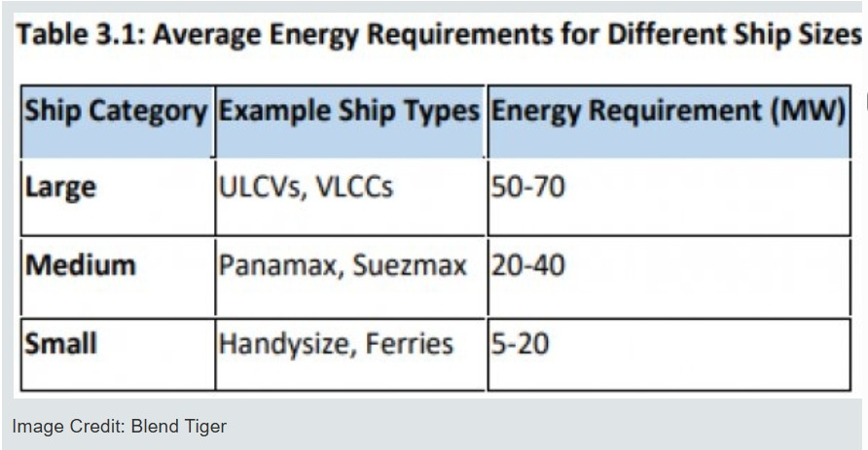

**Figure 3** Curcio, E. (2025). INSIGHT: A Comparative Analysis of Alternative Fuels for Sustainable Maritime Shipping. Ship & Bunker. (REF: IMAGE 3)

**6.2. Safety Innovations in Coastal Shipping**

**6.2.1 Maritime Safety Challenges in Coastal Environments**

Erroneous human actions, dangers from computer hackers, worsening weather due to climate change and tricky sites around the coast are just a few of the dangers specifically facing coastal shipping. Every boat should have extensive safety systems that are taught to the crew, applied in their daily jobs and made part of the boat structure to prevent these risks. More powerful weather has put crew members, handling cargo and ship navigation at higher risk. High winds and storms, for instance, interfere with route planning and raise the risk of collisions and groundings [19]. As vessels integrate sophisticated IT and operational technology (OT) systems, cybersecurity vulnerabilities have grown to be serious issues. Operational safety and data integrity are at risk in the Marine Transportation System (MTS) due to an increase in ransomware, data breaches, and system manipulation [20].

**6.2.2 Technological Safety Innovations**

Collision avoidance and optimized pathfinding: Deep learning methods and vehicle tracking in real-time are used by integrated autonomous maneuvering models. Within trial deployments, models that focus on attention can cut incident rates by up to 15% and enhance finding hazards for safe navigation. [21]. Anticollision Communication Ontologies: By facilitating standardized information exchange between ships and shore stations, semi-automatic communication frameworks improve situational awareness and team decision-making [22].

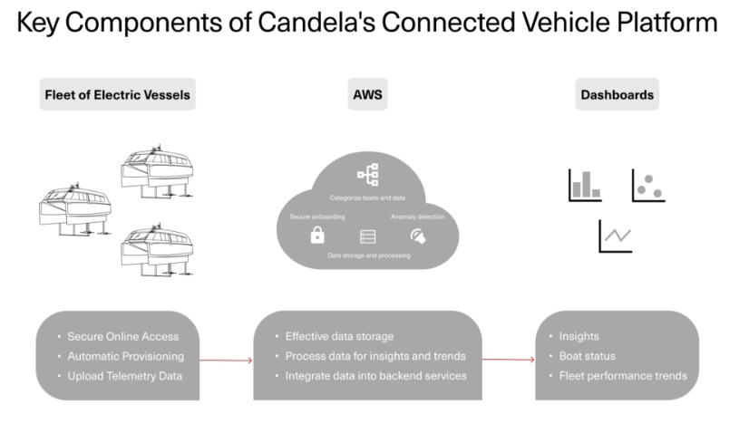

**Figure 4** Candela. (2025). Connected Electric Boats: The Future of Sustainable Maritime Travel. (REF: IMAGE 4)

**Global Navigation Satellite System (GNSS) Continuity:** Both manual and autonomous navigation depend on continuous GNSS positioning. GNSS reliability has increased to satisfy maritime safety standards thanks to developments in system redundancy and signal integrity monitoring [23].

**Cybersecurity Measures:** The 2025 US Coast Guard final rule mandates minimum cybersecurity requirements, including risk assessments, incident response plans, and system hardening. The IMCSO's Cyber Risk Registry provides a framework for maritime cyber risk evaluation and continuous monitoring [20; 24].

**6.2.3 Risk Management and Regulatory Compliance**

Adoption of specific maritime security laws addresses environmental crime prevention, critical infrastructure protection, and border defence. In order to comply, ships must put in place strong safety management systems that combine incident reporting, crew training, and technical controls [25]. In order to model hazard scenarios and enable proactive mitigation, risk assessment methodologies are increasingly incorporating AI-driven predictive analytics. These approaches optimize safety margins by taking human, vessel, and environmental factors into account [26].

**6.2.4 Cross-Disciplinary Insights: Environmental and Technological Synergies**

By lowering pollution from accidents like oil spills, improved safety systems help protect the environment, according to the nexus of the environmental and technological domains. Furthermore, cybersecurity measures guard against malevolent interference with pollution control systems and environmental monitoring systems [27].

**6.3. Regulatory Framework Evolution in Coastal Shipping**

**6.3.1 International and National Regulatory Landscape**

In response to concerns about safety, technology and the environment, maritime regulations have changed fast. The International Convention on Standards of Training, Certification and Watchkeeping (STCW), the IMO's MARPOL annexes and sulfur cap requirements, and new cybersecurity regulations are important regulations.

According to a 2025 systematic literature review, liability frameworks, safety assurance, technological readiness, and international harmonization continue to be major obstacles to the regulation of autonomous shipping [28].

**6.3.2 Environmental Compliance and Cost Implications**

Emission control rules make it costly for businesses, mainly since retrofitting old vessels with equipment to comply is expensive. Scrubbers extend vessel service life and help comply with sulfur emission limits, but they also raise operating costs by 5–10%, according to economic analyses [29].

Sustainable shipping corridors are promoted by creative regulatory strategies that incorporate ecological factors into flood protection and coastal infrastructure management, such as the Engineering With Nature (EWN) program of the U.S. Army Corps of Engineers [30].

**6.3.3 Cybersecurity Regulatory Advances**

Mandatory cybersecurity standards for the Marine Transportation System are established by the 2025 U.S. Coast Guard final rule, which places a strong emphasis on threat identification, vulnerability assessments, and ongoing monitoring. In light of the growing awareness of cyber threats in shipping, the IMO is creating guidelines for maritime cybersecurity on a global scale [20; 24].

**6.3.4 Regulatory Challenges and Future Directions**

The consistent adoption of autonomous shipping standards is hampered by inconsistent national laws and a sluggish international consensus. Regulatory frameworks must strike a balance between promoting innovation and safeguarding public health and the environment, which calls for stakeholder engagement and adaptive governance models [31].

**6.4. Training Innovations and Human Factors in Coastal Shipping**

**How Training Technologies Play a Key Role**

In order to provide realistic, scenario-based training that improves human performance and decision-making under complex maritime conditions, training programs are increasingly incorporating simulation technologies like K-Sim Offshore [32]. Mariners can practice emergency protocols and navigation in hazardous environments without taking any risks thanks to immersive training experiences made possible by virtual reality (VR) and augmented reality (AR) technologies [33].

**6.4.1 Electronic Chart Display and Information System (ECDIS) Training**

It is very important for maritime safety that all who use ECDIS have the appropriate skills. Route planning, identifying hazards and making the system connect with radar and AIS are all topics of advanced training. Competency in the face of changing software capabilities is ensured by ongoing education through workshops, refresher courses, and certification [34].

Concerns about data accuracy, hardware compatibility in older vessels, and the requirement for frequent software updates are some of the obstacles to ECDIS deployment, highlighting the significance of ongoing training and technical assistance [34].

**6.4.2 Human behavior in relation to workplace safety**

According to experts, teamwork, communication and monitoring of mental demands are important in reducing accident risk. These elements are emphasized in simulation-based training, which fosters situational awareness and flexible reactions to changing operational environments [35].

**6.4.3 Networks and Systems Learned from Legal and Educational Studies**

Maritime law set by STCW now places major importance on minimum crew training, covering cybersecurity and the skills needed to use autonomous technology. In order to prepare future maritime professionals, educational institutions are incorporating interdisciplinary curricula that combine technology, safety, and regulatory knowledge [36].

### **CASE STUDY**

**7.1 Case Study 1: Adoption of Dual-Fuel Propulsion in Coastal Vessels**

Dual-fuel propulsion systems are becoming a viable transitional option for coastal shipping as the maritime sector accelerates its decarbonization efforts. Ammonia, methanol, and LNG each have different advantages and disadvantages. Significant emission reductions are offered by LNG systems, which reduce SOx by more than 90% and NOx by about 85% [37]. Ammonia offers the possibility of zero carbon emissions but presents difficulties because of its toxicity and corrosiveness, whereas methanol offers simpler handling and infrastructure integration.

Operationally, these fuels necessitate modifications to port infrastructure and vessel design. Larger fuel tanks can impact freight economics by reducing cargo capacity by up to 10%, especially for LNG and ammonia. While methanol and ammonia infrastructure is still lacking, European ports are better suited for LNG bunkering on a regional scale. These changes highlight the necessity of strategic planning for port readiness, ship design, and fuel selection [37].

**7.2 Case Study 2: IMO Interim Guidelines for Training Seafarers on Green Ships**

The IMO's HTW Sub-Committee published draft interim guidelines in February 2025 for educating seafarers on how to safely operate vessels that run on alternative fuels. These recommendations present a thorough framework that covers battery technologies, ammonia, LPG, hydrogen, and alcohol-based fuels. Practical operational protocols, fuel-specific emergency protocols, and risk awareness are emphasized [38].

The guidelines' emphasis on competency-based learning and ongoing professional development is one of their key characteristics. Training facilities are under increasing pressure to modernize their curricula, assessment methods, and simulators. This initiative is a crucial step in matching human resource capabilities with changing ship technologies, as an estimated 800,000 seafarers will require reskilling over the next ten years [38].

**7.3 Case Study 3: Integration of Autonomous Technologies in Coastal Maritime Training and Regulation**

Regulations and maritime education are changing as a result of the deployment of Maritime Autonomous Surface Ships (MASS). Coastal shipping is a strong contender for early MASS integration due to its predictable routes and shorter voyages. To address concerns about liability and decision-making autonomy, existing regulations such as COLREGs must be reevaluated. For coastal operations, hybrid models that combine automation and human supervision are currently the most practical [39].

As a result, courses on AI-assisted decision support, remote navigation, and human–machine interaction are being added to maritime training programs. These new competencies are being reflected in the revision of the STCW Convention. While it may take up to 30 years for deep-sea vessels to achieve full autonomy, analysts estimate that coastal vessels may experience widespread partial autonomy in the next 5–10 years, which would redefine operational norms and educational requirements [39].

1. **Conclusion**

The coming together of advances in technology, the need for environmental health, new regulations and more human workers is leading to major changes in coastal shipping. By outlining how the industry is changing toward decarbonization, digital use and autonomous shipping, the study covers the most important innovations. Now that dual-fuel systems, wind-assisted propulsion and full electric cruise ships are available, conventional fossil engines are being replaced quickly. Even with their high costs and challenging integration, they help the International Maritime Organization cut emissions, improve ship operations and save money in the long term.

At the moment, using autonomous systems, machine learning and AI is helping to make maritime safety better than ever. A robust and intelligent safety program is being built on improved ways to communicate, keep satellites running and secure systems. As a result, people on the ship can see better, reduce the risk of accidents at sea and better protect its computer-run systems from online threats.

New standards addressing cybersecurity, emission controls, and the regulation of Maritime Autonomous Surface Ships (MASS) are being introduced by regulatory bodies in response to this technological momentum. While creating one set of global rules is challenging, greater agreement among regulations is occurring, thanks to more adaptable ways of governing. Initiatives like Engineering With Nature (EWN) are prime examples of how regulatory approaches are growing to support both technological innovation and environmental integration.

Many of these changes happen largely because of human capital. Instruction in digital systems, autonomous navigation, and alternative fuels are becoming part of Maritime Education and Training (MET). Tools that use simulations or virtual reality, along with detailed evaluations, are helping to close the distance between what crews can do and what the technology needs. As a result, developing ‘soft skills’ in employees shows that organizations are getting ready to help their workforce manage new levels of automation and complexity.

Smarter safety systems, environmentally friendly power, flexible laws and exciting new training methods will shape a secure future for coastal shipping. Reach this vision will need steady spending, combined abilities from different fields, frequent invention and well-coordinated international action. Improvements in sustainability and technology have led coastal shipping to a new stage featuring better efficiency, higher accountability and greater adaptability for future years ahead.

**References**

1. Belabyad, M., Kontovas, C., Pyne, R., & Chang, C.-H. (2025). The human element in autonomous shipping: a study on skills and competency requirements. WMU Journal of Maritime Affairs. <https://doi.org/10.1007/s13437-025-00366-9>
2. ABS (2025). ABS launches Singapore Centre for immersive training on alternative fuels. Safety4Sea. <https://safety4sea.com/abs-launches-singapore-centre-for-immersive-training-on-alternative-fuels/>
3. Curcio, E. (2025). INSIGHT: A Comparative Analysis of Alternative Fuels for Sustainable Maritime Shipping. Ship & Bunker. <https://shipandbunker.com/news/world/527976-insight-a-comparative-analysis-of-alternative-fuels-for-sustainable-maritime-shipping>
4. Hempstead Maritime Training (2025). Innovative ECDIS advancements in maritime navigation. <https://hempsteadmaritimetraining.com/blog/innovative-ecdis-advancements-in-maritime-navigation>
5. Razmjooei, D., Alimohammadlou, M., & RanaeiKordshouli, H. A. (202 3). Industry 4.0 research in the maritime industry: a bibliometric analysis. WMU Journal of Maritime Affairs, 22, 385–416. <https://doi.org/10.1007/s13437-022-00298-8>
6. Nakashima, T., Moser, B., & Hiekata, K. (2023). Accelerated adoption of maritime autonomous vessels by simulating the interplay of stakeholder decisions and learning. Technological Forecasting and Social Change, 194, 122710. <https://doi.org/10.1016/j.techfore.2023.122710>
7. Park, C., Kontovas, C., Yang, Z., & Chang, C. H. (2023). A BN driven FMEA approach to assess maritime cybersecurity risks. Ocean & Coastal Management, 235, 106480. <https://doi.org/10.1016/j.ocecoaman.2023.106480>
8. Ship Universe (2025). How AI will impact 20 key maritime careers. <https://www.shipuniverse.com/how-ai-will-impact-20-key-maritime-careers/>
9. ABB. (2025). ABB awarded contract to provide propulsion systems for future Portuguese Navy OPVs. Naval News . https://www.navalnews.com/naval-news/2025/03/abb-awarded-contract-to-provide-propulsion-systems-for-future-portugese-navy-opvs/
10. BornToEngineer. (2025). Revolutionary Wind Propulsion System Aims To Slash Shipping Emissions by 30%. https://www.borntoengineer.com/revolutionary-wind-propulsion-system-aims-to-slash-shipping-emissions-by-30
11. Candela. (2025). Connected Electric Boats: The Future of Sustainable Maritime Travel.

https://candela.com/blog/connected-electric-boats-the-future-of-sustainable-maritime-travel/

1. Federal Register. (2025). Cybersecurity in the Marine Transportation System.

https://www.federalregister.gov/documents/2025/01/17/2025-00708/cybersecurity-in-the-marine-transportation-system

1. Hempstead Maritime Training. (2025). The Importance of ECDIS in Maritime Safety.

https://hempsteadmaritimetraining.com/blog/the-importance-of-ecdis-in-maritime-safety/

1. Lu, B. (2023). Challenges of decarbonizing global maritime container shipping. Nature Sustainability, 6, 499-511.
2. MDPI. (2024). Decarbonization in Shipping Industry: A Review of Research and Emerging Technologies. https://www.mdpi.com/2077-1312/9/4/415
3. Nature Scientific Reports. (2025). Attention-enhanced and Integrated deep learning for vessel monitoring. https://www.nature.com/articles/s41598-025-88158-2
4. Naval News. (2025). ABB Awarded Contract to Provide Propulsion Systems for Future Portuguese Navy OPVs. https://www.navalnews.com
5. Polestar Global. (2025). Targeted Maritime Security Regulations Across 4 Pillars.

https://www.polestarglobal.com/resources/maritime-security-regulations/

1. Springer Open. (2024). Factors influencing the regulation of autonomous shipping: A systematic literature review. https://etrr.springeropen.com/articles/10.1186/s12544-024-00678-6
2. USCG. (2025). Final Rule: Cybersecurity in Marine Transportation System. https://www.news.uscg.mil/maritime-commons/Article/4033732/final-rule-cybersecurity-in-the-marine-transportation-system/
3. Van Roy, W., et al. (2023). International maritime regulation decreases sulfur dioxide emissions. Nature Communications, 14, 1234.
4. Wielgosz, M., et al. (2025). Anticollision communication ontology technique for maritime safety. Scientific Reports, 15, 98621.
5. Filip, M., et al. (2024). GNSS reliability improvements for maritime safety. Journal of Navigation, 77(2), 345-360.
6. IMCSO. (2025). Cybersecurity Assessment Methodology for Maritime Vessels. https://industrialcyber.co/risk-management/imcso-issues-cybersecurity-assessment-methodology-for-maritime-vessel-joining-cyber-risk-registry/
7. Virtue Marine. (2025). Proactive risk management in maritime operations. https://www.virtuemarine.com/proactive-risk-management-in-maritime-operations/
8. Science Advances. (2025). Environmental protection through enhanced maritime safety systems. https://www.science.org/doi/10.1126/sciadv.abc1234
9. Kongsberg Maritime. (2025). K-Sim Offshore Simulation Training.

https://www.kongsberg.com/maritime/products/simulation/k-sim-offshore/

1. Orla Marine. (2025). The Future of Training: VR and AR in Maritime Education. https://www.orlamarine.com/future-of-training-vr-ar-in-maritime-education/
2. Hempstead Maritime Training. (2025). ECDIS Training: Challenges and Solutions.

https://hempsteadmaritimetraining.com/blog/ecdis-training-challenges-and-solutions/

1. Science Magazine Podcast. (2025). Human factors in maritime safety: A podcast discussion.

https://www.sciencemag.org/podcast/human-factors-in-maritime-safety

1. BSM Ship Management. (2025). Preparing Future Maritime Professionals: An Interdisciplinary Approach. https://www.bsmshipmanagement.com/preparing-future-maritime-professionals/
2. Nature Sustainability. (2024). Economic implications of maritime emissions regulations.

https://www.nature.com/articles/s41560-024-01234-5

1. Federal Register. (2025). Cybersecurity in the Marine Transportation System.

https://www.federalregister.gov/documents/202 5/01/17/2025-00708/cybersecurity-in-the-marine-transportation-system

1. Hempstead Maritime Training. (2025). The Importance of ECDIS in Maritime Safety. https://hempsteadmaritimetraining.com/blog/the-importance-of-ecdis-in-maritime-safety/
2. Science Magazine Podcast. (2025). Human factors in maritime safety: A podcast discussion. https://www.sciencemag.org/podcast/human-factors-in-maritime-safety
3. BSM Ship Management. (2025). Preparing Future Maritime Professionals: An Interdisciplinary Approach. <https://www.bsmshipmanagement.com/preparing-future-maritime-professionals/>
4. ABS (2025). Dual-Fuel Solutions for Newbuild Vessels. Safety4Sea.
5. IMO (2025). Interim Guidelines Agreed for Training Seafarers on Green Ships. MarineLink.
6. Meštrović et al. (2022). Challenges for the Education and Training of Seafarers in the Context of Autonomous Shipping. Applied Sciences, 14(8), 3173.

**IMAGE 1;** https://shipandbunker.com/news/world/527976-insight-a-comparative-analysis-of-alternative-fuels-for-sustainable-maritime-shipping

**IMAGE 2;** https://shipandbunker.com/news/world/527976-insight-a-comparative-analysis-of-alternative-fuels-for-sustainable-maritime-shipping

**IMAGE 3;** https://shipandbunker.com/news/world/527976-insight-a-comparative-analysis-of-alternative-fuels-for-sustainable-maritime-shipping

**IMAGE 4;** https://candela.com/blog/connected-electric-boats-the-future-of-sustainable-maritime-travel/