**International Journal of Science And Engineering**

[ISSN (Online):](http://oapub.org/edu/index.php/ejes) 2454-2016

[Volume 11 Issue 01 May 202](http://oapub.org/edu/index.php/ejes)5

**DOI:** **10.53555/ephijse.v11i1.308**

STUDY ON FABRICATION OF ECO EVAPORATOR AND PRODUCING

DRINKABLE WATER FROM THE WASTE WATER OF STANDING WATER BODIES

**Prof . Manjunath Sharanappanavar1*, Sahilkumar Naik2, Mahantesh Biradar3, Sachin Wali4, Vinayak Majukar5**

*1Project Guide, Department of Civil Engineering, S.G. Balekundri Institute of Technology, Belagavi, Karnataka, India*

*2,3,4.,5Student, Department of Civil Engineering, S.G. Balekundri Institute of Technology, Belagavi, Karnataka, India*

*‘*Corresponding Author: Email: Sharanappanavarmanju@gmail.com*

**ABSTRACT:** Water scarcity remains a critical challenge globally, with millions of people lacking access to clean drinking water. This project explores the development of a simple, solar-powered water purification system designed to address water contamination issues in areas with limited access to electricity. The solar still uses the sun's energy to evaporate water, leaving impurities behind, and then condenses the vapor to produce clean, drinkable water. The study focuses on the effectiveness of this solar still in purifying water from Kanbargi Lake, which exhibited high levels of contamination including elevated pH, TDS, EC, turbidity, and BOD. The results showed significant improvements in water quality, with reduced turbidity, lower TDS and EC, and a notable decrease in BOD, making the water safer for consumption. This simple, sustainable technology has the potential to address water quality issues in remote and underserved regions. Furthermore, the future scope of the technology includes scaling up the system, integrating it with other purification methods, and incorporating renewable energy sources for enhanced efficiency. By empowering local communities to manage their water purification needs, this technology offers a promising, eco-friendly solution to the global water crisis.

**KEYWORDS:** Fabrication, pH of water , Total solid waste , EC-TDS of water , Turbidity , Hardness of water , BOD of water .

Copyright 2025 IJSE

Distributed under Creative Commons CC-BY 4.0 OPEN ACCESS

# 1.INTRODUCTRION

In today's world, access to clean water is crucial, yet millions of people still do not have it. To tackle this issue, we are developing a straightforward, solar-powered water purifier that harnesses the sun's energy to purify contaminated water. Our aim is to make it both affordable and easy to construct, particularly for communities that lack reliable electricity. By promoting this project, we hope to motivate others to devise their own solutions and strive for a future where clean water is available to everyone.

**1.1 Brief discussion on water quality test 1.1.1 pH of water** pH is a measure of how acidic or basic water is, ranging from 0 to 14, with 7 being neutral. Values below 7 are acidic, and values above 7 are alkaline, with each step representing a tenfold change in acidity or basicity. Several factors influence water's pH, including the concentration of carbon dioxide, temperature, and the presence of carbonate and bicarbonate ions. High CO2 levels can lower pH, making water more acidic, while temperature changes can affect CO2 solubility and impact pH. Organic material decomposition also releases carbon dioxide, further altering water’s acidity.

## 1.1.2 Total suspended solids

Total Suspended Solids (TSS) refer to particles in water that are larger than 2 microns, like sand, sediment, algae, and bacteria. These particles can cloud the water, affecting its clarity. Common sources of TSS include bacteria, clay, gravel, sand, and silt. While clay and sand may not be harmful in small amounts, they can impact the taste, odor, and appearance of water. TSS is typically measured with a sensor or through laboratory tests, helping to assess the quality of water, especially in wells or contaminated sources.

## 1.1.3 EC-TDS of water

An EC (Electrical Conductivity) meter measures how well water can conduct electricity, which is influenced by the number of dissolved ions in it. This helps in determining water quality, as higher conductivity usually means higher levels of dissolved solids or salts. Conductivity is typically measured in µS/cm or mS/cm, with seawater having very high conductivity compared to freshwater. Since EC readings can be affected by temperature, it's important to measure and compensate for temperature changes to get accurate results.

## 1.1.4 Hardness of water

Hard water contains high levels of minerals like calcium and magnesium, often from passing through chalk or limestone. While it's safe to drink, it can cause problems over time, like skin irritation, soap not lathering well, and leaving spots on clothes. There are two types of hardness: temporary, which can be removed by boiling, and permanent, which requires treatment with washing soda to soften. Hard water can also damage appliances and increase water bills due to the extra work they need to do.

## 1.1.5 BOD of water

Biochemical Oxygen Demand (BOD) testing measures the amount of oxygen needed to break down organic material and oxidize certain inorganic substances in wastewater. The test is done by comparing dissolved oxygen levels before and after a 5-day incubation period at 20°C. Samples are typically collected as 24-hour composites to accurately represent wastewater flow, and they must be kept at a temperature below 6°C until analysis. This helps ensure accurate results, as BOD gives insight into the water's ability to support aquatic life and how much oxygen-consuming material is present.

## 1.2 Research objectives

1. To analyze the physical and chemical properties of lake or pond water.
2. To fabricate the eco evaporator for validating the concept.
3. To produce clean and drinkable water from the waste water through eco evaporator.

## 1.3 Importance of this study

Researching the development of eco-evaporators to create drinkable water from wastewater in stagnant water bodies is essential in light of the increasing global issues of water scarcity and pollution. This method provides a sustainable and energy-efficient way to purify contaminated water, especially in areas where access to clean water is limited. By implementing this approach, we can help decrease waterborne diseases, improve public health, and promote environmental sustainability. Furthermore, it supports worldwide initiatives aimed at ensuring clean water and sanitation for everyone.

# 2. METHODOLOGY

## 2.1 Fabrication process

### 2.1.1 Materials

|  |  |
| --- | --- |
| **Materials** | **Quantity used in project** |
| LDPE plastic | 6mtr |
| Flexible pipe | 2mtr |
| Funnel | 5.14mtr |
| Thick galvanized steel rod | 1.9mtr diameter of 2 circle and 1.5mtr of 8 rod |

### 2.1.2 Design and planning of fabrication

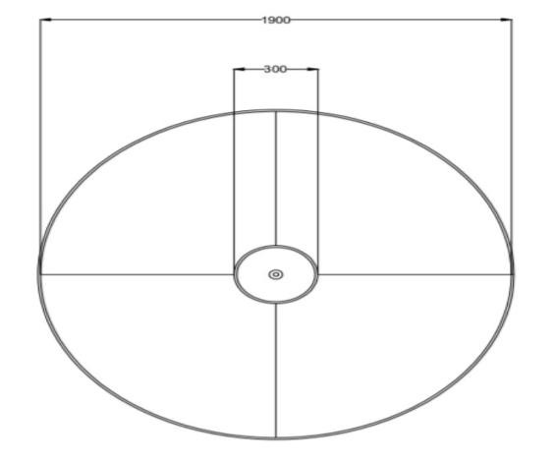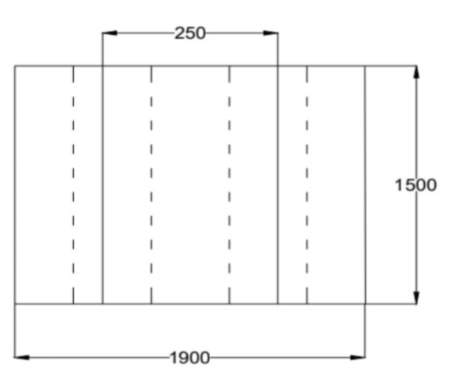

# Fig 1. upper observation of the fabrication Fig 2 . upper observation of the fabrication

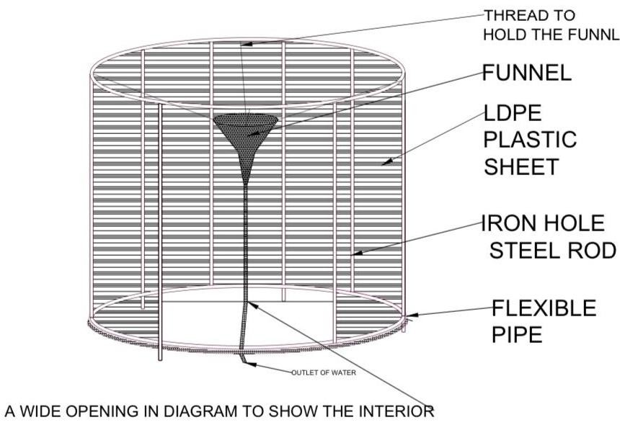

# Fig 3. overall plan of fabrication

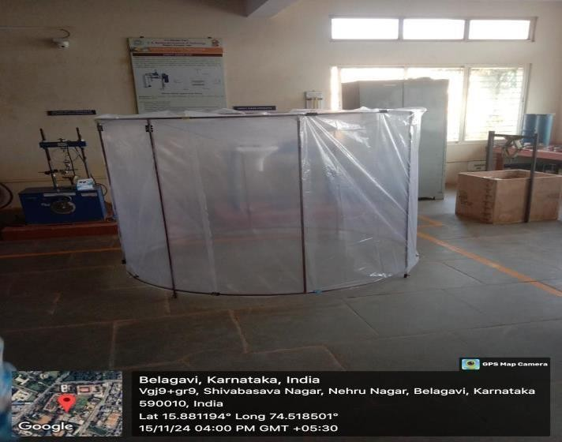

# Fig 4. fabrication

## 2.1.3 Final fabrication

The design is a huge, solar-powered water purification filter. It uses a large tire frame covered with plastic sheeting. One places this frame inside any body of water. The sun heats the air within the frame, where the water evaporation takes place. The condensed vapor falls onto the inside of the plastic sheeting and drips down into a collection tube. This purified water can then be collected and used.The filter is simple and low cost. It does not need any electricity or other power source. It is also quite easy to build and maintain.

However, its efficiency is not very good because it could only provide a small amount of water per day.The filter is not yet fully developed, but its creator feels that it can make a real difference for people without access to clean water.

**Frame Construction**: A metal rod is used in creating a rigid frame.

**Plastic Wrapping**: A big sheet of plastic is gently spread and attached over the frame. It then creates a closed envelope. The final assembly and sealing also entail that the plastic is tight on the frame for a leak-proof space.

## 2.2 Procedure

1. To create a solar water purifier, start by constructing a large, circular frame using PVC pipes or similar materials. This frame will serve as the foundation for the purifier.
2. Next, build an inner structure within the frame using mesh or netting material to support the water collection system.
3. Attach a series of tubes or pipes to this inner structure for collecting the purified water.
4. Carefully place the entire frame into a water body, like a lake or pond, ensuring it is submerged and stable.
5. Cover the frame with a large sheet of plastic or a similar material to create an airtight seal, trapping the water vapor inside.
6. Let the sun heat the water within the frame, causing it to evaporate.
7. As the water vapor rises, it will condense on the inner surface of the plastic covering.
8. The condensed water will then drip down and collect in the tubes or pipes attached to the inner structure.
9. Finally, extract the purified water from the tubes or pipes.
10. Test the collected water for purity and make any necessary adjustments to the design or process to enhance efficiency.

# 3.RESULT & DISCUSSION

## 3.1 Ph of raw water and evaporated water

|  |  |  |
| --- | --- | --- |
| **Sl.no** | **RAW WATER** | **EVAPORATED WATER** |
| **1** | 7.30 | 6.7 |
| **2** | 7.38 | 6.55 |
| **3** | 7.32 | 6.65 |
| **Avg** | 7.3 | 6.58 |

**Conclusion:**

As per BIS drinking water must have 6.5-7 in the sample . As we can see Raw water Is not drinkable and evaporated water is drinkable.

**3.2 Total solids in raw water and evaporated water**

|  |  |  |  |
| --- | --- | --- | --- |
| Description |  | Weight (g) for raw water Weight (g) **for evaporated water** | |
| Weight of dish(g) | W1 | 33.2078 g | 33.4008 g |
| Weight of dish + raw water (g) | W2 | 33.2496 g | 33.4296 g |
| Weight of residue (g) | W | 0.0418 g | 0.0288 g |
| Volume of raw water ml | V | 25 ml | 25 ml |
| **Total solids (mg/l)** | TS | 80 mg/l | 384 mg/l |

**Conclusion:**

As per BIS 557 mg/L of total solids in raw water isn’t acceptable for drinking water .

and 384 mg/L of total solids in evaporated water is acceptable for drinking water .

## 3.3 EC-TDS of raw water and evaporated water

|  |  |  |  |  |
| --- | --- | --- | --- | --- |
| Reading | EC meter (ms) of raw water | TDS meter (ppm)of raw water | EC meter (ms) **of evaporated water** | TDS meter (ppm) evaporated water |
| 1 | 1124 | 264 | 23.8 | 464 |
| 2 | 1125 | 266 | 24.0 | 466 |
| 3 | 1122 | 262 | 26.50 | 462 |
| Avg | **1123.66** | **264** | **24.7** | **464** |

**Conclusion:**

The water sample has a TDS value within the BIS desirable limit, making it safe for drinking.

The EC value is also in an acceptable range, indicating a moderate level of dissolved ions. No significant salinity or contamination is suggested by these readings.

|  |  |  |
| --- | --- | --- |
| Sl.no | Result in NTU of raw water | Result in NTU of evaporated water |
| 1 | 7.7 | 3.8 |
| 2 | 7.2 | 3.5 |
| 3 | 7.3 | 3.5 |
| Avg | 7.4 | 3.6 |

**3.4 Turbidity of raw water and evaporated water**

**Conclusion:** As per BIS standard 7.4 NTU isn’t acceptable for drinking and 3.6 NTU is acceptable for drinking.

## 3.5 Hardness of raw water and evaporated water

|  |  |  |  |  |  |
| --- | --- | --- | --- | --- | --- |
| **Details** | **Volume of sample (ml)** | **Initial reading**  **(ml)** of raw water | **Final reading (ml)** raw water | **Initial reading**  **(ml) of evaporated water** | **Final reading (ml) of evaporated water** |
| **Total hardness** | 50ml | 4.1 | 6.9 | 1 | 2.6 |
| **TH** | 50ml | 11.5 | 6.9 | 2.6 | 1.5 |
| **TH** | 50ml | 17.9 | 6.5 | 4.1 | 1.5 |
| **Avg** | - | - | 6.5 | - | 1.86 |

**Conclusion:** As per BIS the raw was found to be hard and the evaporated was found to be soft.

**3.6 B.O.D of raw water and evaporated water**

# Day 1 testing of raw water

|  |  |  |  |  |
| --- | --- | --- | --- | --- |
| **Volume e sample (ml)** | **Initial DO (mg/l)** | **Final DO (mg/l)** | **DO dilution (mg/l)** | **Avg** |
| 2 | 7 | 13 | 6 | - |
| 2 | 13 | 19.4 | 6.4 | 6.46 |
| 2 | 19.4 | 26.4 | 7 | - |

# Day 7 testing of raw water

|  |  |  |  |  |
| --- | --- | --- | --- | --- |
| **Volume e sample (ml)** | **Initial DO (mg/l)** | **Final DO (mg/l)** | **DO dilution (mg/l)** | **Avg** |
| 2 | 1 | 8 | 7 | - |
| 2 | 8 | 15.4 | 7.4 | 7.0 |
| 2 | 15.4 | 22.5 | 7.1 | - |

# Day 1 testing of evaporated water

|  |  |  |  |  |
| --- | --- | --- | --- | --- |
| **Volume e sample (ml)** | **Initial DO (mg/l)** | **Final DO (mg/l)** | **DO dilution (mg/l)** | **Avg** |
| **2** | 1 | 7 | 6 | - |
| **2** | 7 | 13 | 6 | 5.3 |
| **2** | 13 | 17 | 4 | - |

# Day 7 testing of evaporated water

|  |  |  |  |  |
| --- | --- | --- | --- | --- |
| **Volume e sample (ml)** | **Initial DO (mg/l)** | **Final DO (mg/l)** | **DO dilution (mg/l)** | **Avg** |
| **2** | 0 | 2.1 | 2.1 | - |
| **2** | 2.1 | 5.1 | 3 | 2.5 |
| **2** | 5.1 | 7.5 | 2.4 | - |

**Conclusion:**

As per BIS for ordinary domestic range to be discharge into surface water bodies must have BOD of less than 30mg/l for given sample.

# 4.CONCLUSION

The water obtained from Kanbargi Lake was highly contaminated and not fit for drinking purposes due to its pH, TDS, EC, turbidity, hardness, and BOD values. However, one advantage of this case was that the solar still was quite effective in evaporating the water by harnessing the energy from the sun and leaving the impurities behind. The quality of the resulting water was far better, showing improved pH values, lower TDS and EC, reduced turbidity, and a significant reduction in BOD, making the water safer to drink. This makes solar stills a simple yet sustainable means to improve water quality in areas lacking clean water supply.

# 5.REFERNCES

1. **Abtew, W.** (**2001**) Evaporation estimation for Lake Okeechobee in South Florida. 127 3 140-147.
2. **Burman, R. and Pochop, L.O.** (**1994**) Evaporation, evapotranspiration and climatic data. In Developments in Atmospheric Science 22. New York. Elsevier Science B.V. 39) .
3. **Chen, J.H., Kan, C.E., Tan, C.H. and Shih, S.F. (2002)** Use of spectral information for wetland evapotranspiration assessment. Agric. Water Mgmt 55 239-248 40) .
4. **Chiew, F.H.S., Kamaladassa, N.N., Malano, H.M., and McMahon, T.A**. (**1995**) Penman-Monteith FAO reference crop evapotranspiration and class-A pan data in Australia. Agric. Water Mgmt 28 1 9-21 41)
5. **Christiansen, C., and Worlton, L.** (**1998**) Reduced set evaporation station. Irrig. J 48 5 12-14 42)
6. **Clewitt, J.F.** (**1980**) Shallow Storage Irrigation for Sorghum Production in North-West Queensland, QDPI Bulletin QB85002
7. **Croley, T.E.** (**1989**) Verifiable evaporation modelling on the Laurentian Great Lakes. Water Resour. Res. 25 781792 55).
8. **Crow, F.R. and Manges, H.L.** (**1967)** Comparison of chemical and non-chemical techniques for suppressing evaporation from small reservoirs. Trans ASAE 10 172-174 .
9. **Chiew, F.H.S., Kamaladassa, N.N., Malano, H.M., and McMahon, T.A. 1995** Penman-Monteith FAO reference crop evapotranspiration and class-A pan data in Australia. Agric. Water Mgmt 28 1 9-21 41)
10. **Christiansen, C., and Worlton, L. 1998** Reduced set evaporation station. Irrig. J 48 5 12-14 42) .
11. **Christiansen, J.E. 1968** Pan evaporation and evapotranspiration from climatic data. J. Irrig. Drain. Eng. 94 243265 43).
12. **Clewitt, J.F. 1980** Shallow Storage Irrigation for Sorghum Production in North-West Queensland, QDPI Bulletin QB85002
13. **Croley, T.E. 1989** Verifiable evaporation modelling on the Laurentian Great Lakes. Water Resour. Res. 25 781792 55).
14. **Crow, F.R. and Manges, H.L. 1967** Comparison of chemical and non-chemical techniques for suppressing evaporation from small reservoirs. Trans ASAE 10 172-174 .